

La Salle University
College of Computer Studies, Engineering, and Architecture

SystAdmin

LABORATORY 7-9
Deploying and Managing Azure Compute Resources
(ARM Template + CLI Code)

Open Azure Portal
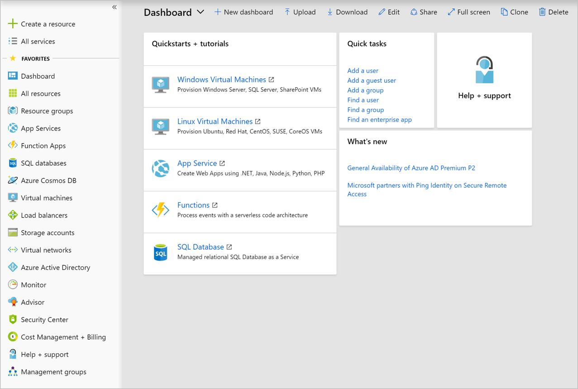
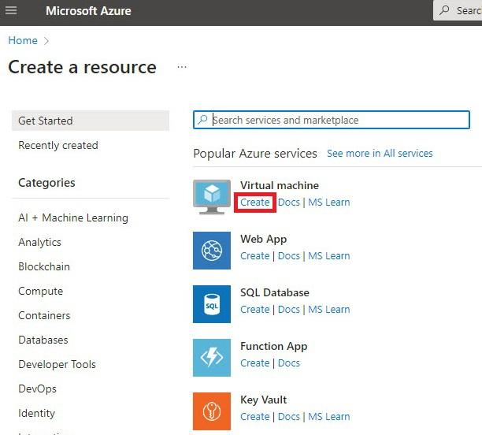
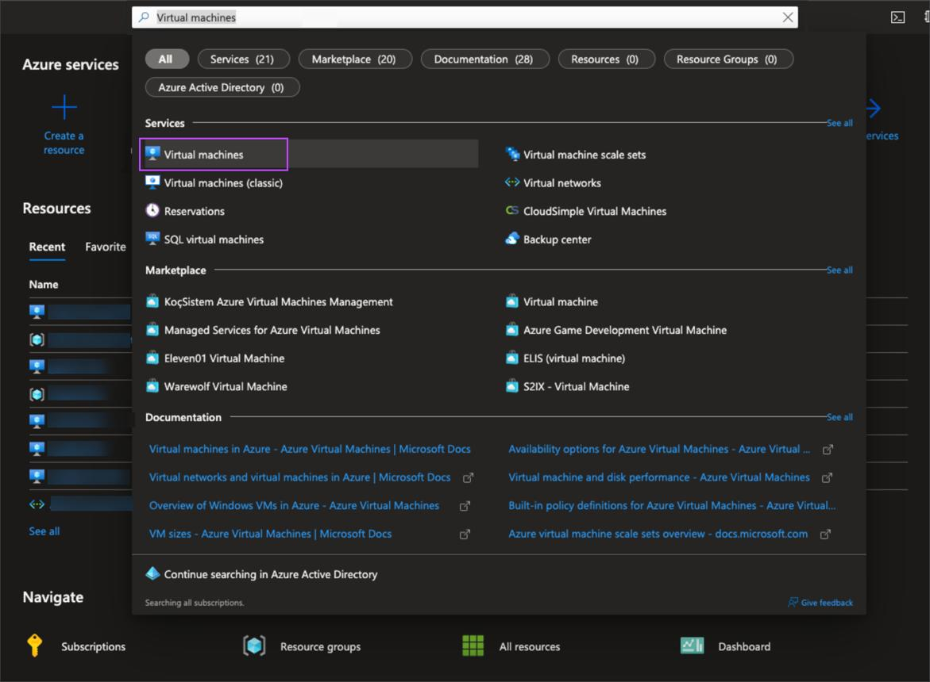
6
- Go to https://portal.azure.com
- Search Virtual Machines (for verification later)

3. Create ARM Template in VS Code
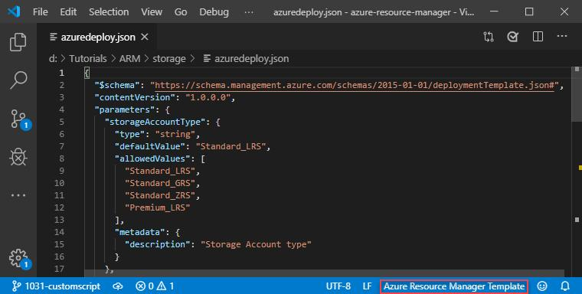
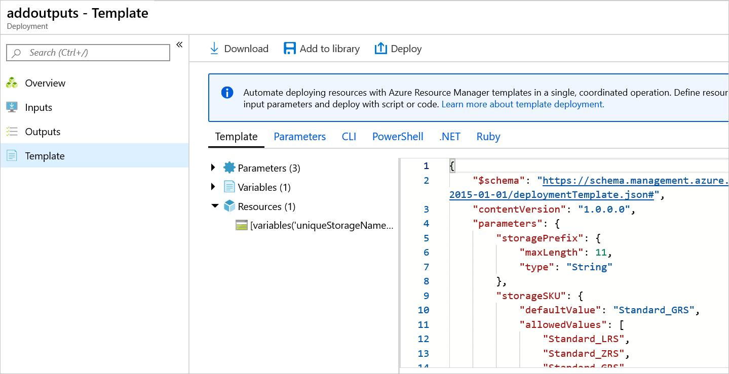
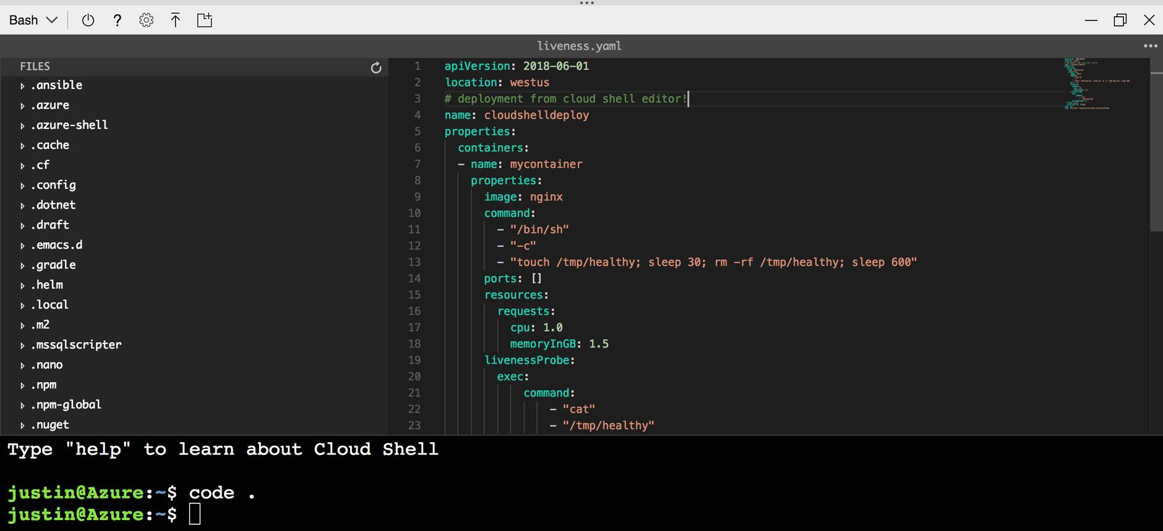
6
- Open Visual Studio Code
- Create a file:
azuredeploy.json
- Paste the ARM template below.

📄 ARM Template (JSON File)
{
"$schema": "https://schema.management.azure.com/schemas/2019-04-01/deploymentTemplate.json#",
"contentVersion": "1.0.0.0",
"parameters": {
"vmName": {
"type": "string",
"defaultValue": "myVM"
},
"adminUsername": {
"type": "string"
},
"adminPassword": {
"type": "secureString"
}
},
"resources": [
{
"type": "Microsoft.Compute/virtualMachines",
"apiVersion": "2024-03-01",
"name": "[parameters('vmName')]",
"location": "[resourceGroup().location]",
"properties": {
"hardwareProfile": {
"vmSize": "Standard_B1s"
},
"osProfile": {
"computerName": "[parameters('vmName')]",
"adminUsername": "[parameters('adminUsername')]",
"adminPassword": "[parameters('adminPassword')]"
},
"storageProfile": {
"imageReference": {
"publisher": "Canonical",
"offer": "UbuntuServer",
"sku": "18.04-LTS",
"version": "latest"
}
},
"networkProfile": {
"networkInterfaces": []
}
}
}
],
"outputs": {
"vmName": {
"type": "string",
"value": "[parameters('vmName')]"
}
}
}

4. Open Terminal in VS Code
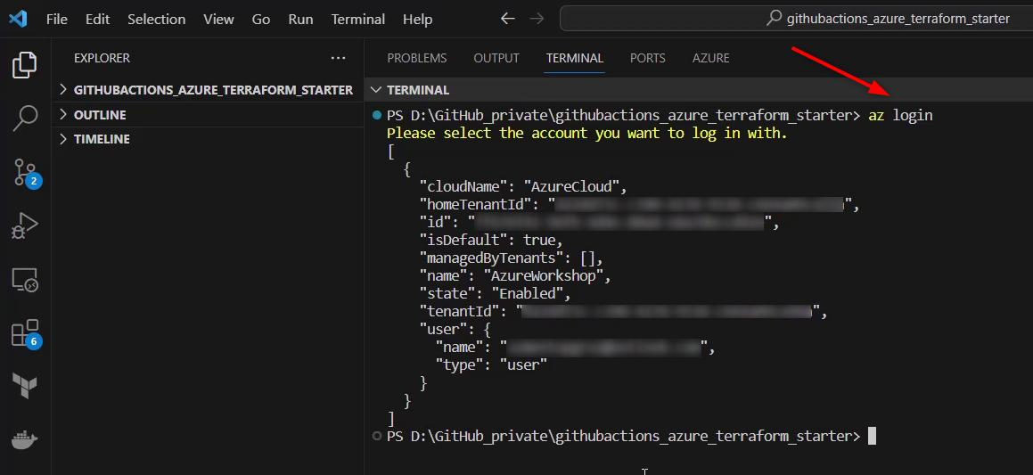
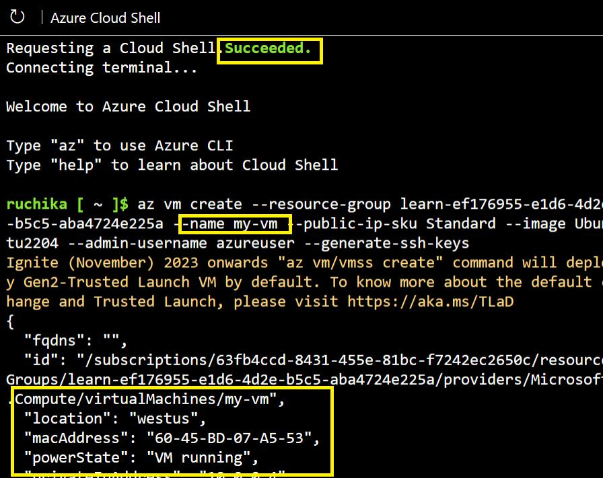
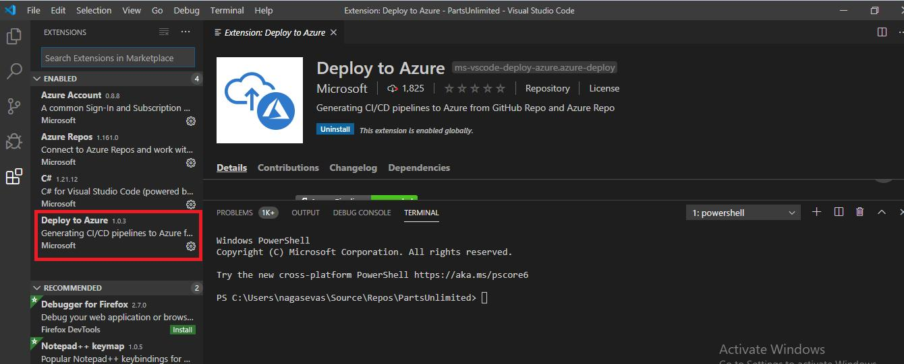
7
- Go to Terminal → New Terminal
- Ensure Git Bash or Bash is selected

5. Login to Azure
az login
- Browser opens → sign in
- Select subscription if prompted

6. Create Resource Group
az group create \
--name RG1 \
--location eastus

7. Set Default Resource Group
az configure --defaults group=RG1

8. Deploy ARM Template (Compute Resource)
templateFile="azuredeploy.json"
today=$(date +"%d-%b-%Y")
DeploymentName="vmdeploy-"$today

az deployment group create \
--name $DeploymentName \
--template-file $templateFile

9. Verify Deployment in Azure Portal
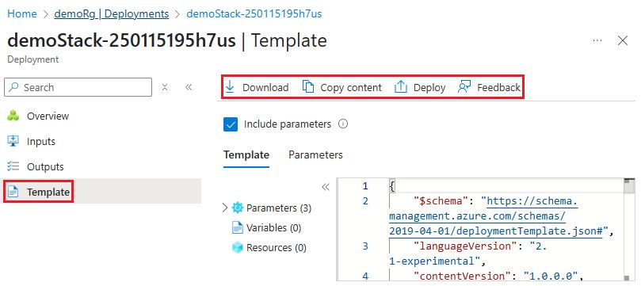
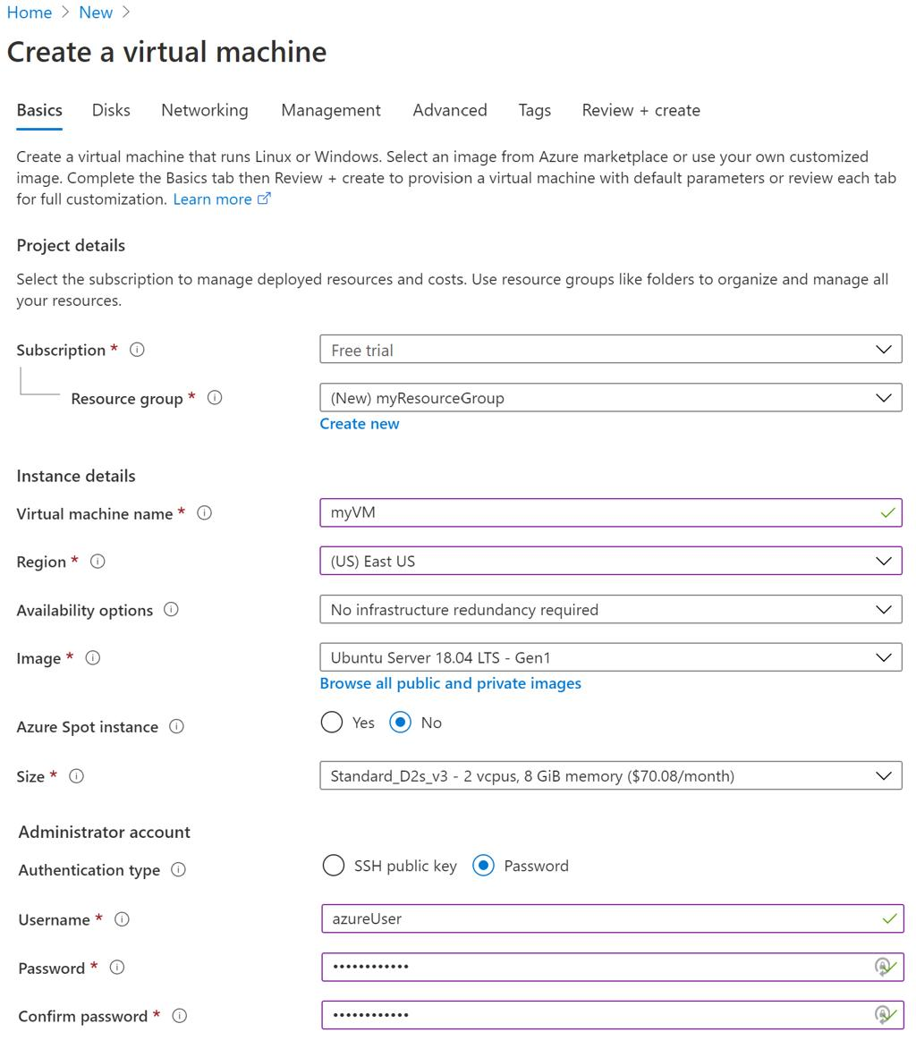
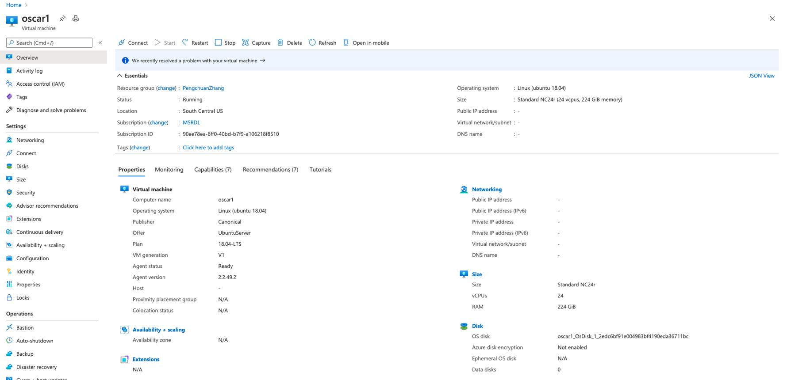
5
- Go to Resource Group → RG1
- Click Deployments
- Check status = Succeeded
- Open Virtual Machines
- Verify VM is created

🧠 Key Management Actions (Optional CLI)

Stop VM
az vm stop --name myVM

Start VM
az vm start --name myVM

Delete VM
az vm delete --name myVM --yes

